**Assignment**

1. **What is SDLC?**

- SDLC is a **Software Development Life Cycle**. SDLC is process used by software development.

**What is SDLC process?**

* SDLC is a process that follows in Software Projects to develop a product in a systematic way and to deliver a high-quality product.
* This process involves different stages of SDLC right from the requirement stage to deployment and maintenance phase.

**Why SDLC is important?**

* Some of the reasons why SDLC is important in Software development are as follow.
  + - * It allows us to track and control the project
* It helps us to avoid project risks
* Efficient with regard to costs
* Enhances teamwork and coordination, defines suitable roles for employees and increases workplace transparency.

**There are 7 SDLC phases are as follows:-**

1. Requirement phase
2. Analysis phase
3. Design phase
4. Development phase
5. Testing phase
6. Deployment and maintenance phase.
7. **What is Software Testing?**

* Software testing is a process that evaluates a software applications functionality, performance, and quality to ensure it meets the user’s requirements and is free of bugs/defects.

Or

* Software testing is process of assessing the funtionlity of a software program. The process checks for errors and gaps in software products before the software is installed and goes live.

**Purpose:-** - Software testing is a critical process that help prevent bugs, improve performance and ensure the software meets all specified requirements.

**Benefits:-** Software testing helps minimize risk by finding issues early in the development phase.

1. **What is agile methodology?**

**Defintion:** Agile methodologies propose incremental and iterative approach to software design.

* Agile methodology is a software development framework that emphasizes collaboration, flexibility and customer feedback.
* Agile methodology is combination of iterative and increment model. In this methodology that helps developers test their code continuously and rapidly and also allows testers to get immediate feedback from customers.
* In this methodology, a big project are divided into smaller parts.
* Here are some characteristics of agile testing:-
* **Collaboration:** The entire team works together, including people with expertise in programming business analysis and more.
* **Continuous testing:** Developers test their code quickly and continuously.
* **Customer feedback:** Testers get immediate feedback from customers.
* **Breaking down testing:** Larger testing element are broken down into smaller, more specific tests.
* **Iterative progress:** The agile cycle allows for short iterations, making it easy to make changes.

1. **What is SRS**

* SRS stand for Software Requirement Specifications is a document that describes what the software will do and how it will be expected to perform.
* An SRS document includes:
* The project high level business requirements.
* End user requirements and needs
* The product’s funtionlity in technical terms
* How the applications will interact with system hardware, other program and human users.
* Parameters such as operating speed, response time, availability, maintainability and speed of recovery.
* An SRS document can be thought of a blueprint or roadmap for the software developed.

**Why use an SRS documents?**

* An SRS gives you a complete picture of your entire project. It provides a single source of truth that every team involved in development will follow. It is your plan of action and keeps all your teams from development and testing to maintenances on the same page.
* SRS document include two types of requirements.

**Types of Requirements:-**

1. Customer requirement
2. Functional requirement
3. Non-functional requirement

Functional Requirement: -

* Functional requirement describes what the product does or system behaviour under specific conditions.
* These define the software’s capabilities, behaviours and processes. They include design, graphics, operating system requirement and constraints.
* Functional requirement are different types like authentication, authorization levels, data processing, reporting etc.

Non- Functional Requirement: -

* Non- functional requirements are not related to the system’s funtionlity but rather define how the system should perform.
* Non- functional requirement is including different types like usability, reliability, scalability, performance and security etc.

Customer requirement: -

* Customer requirements are the features or specifications of a product or service that customers consider necessary.
* They are the specific needs, wants, or expectations that a product or service must meet to be successful.
* Some examples of customer requirements include:
* Functional specifications, performance standards, design constraints, user experience and cost- effectiveness.

**5. What is oops?**

- oops is a object oriented programming & systems. Oops is a computer programming model that organizes software around objects, rather than functions and logic.

- The concept of object which contain data, in the form of fields and code in the form of procedures.

**6. Write basic concepts of oops.**

- Oops stand for object oriented programming system. Here are some examples of oops concept: -

1. object

2. Inheritance

3. Polymorphism

4. Abstraction

5. Class

6. Encapsulation

**7. What is object?**

**-** Object is an instance of class that encapsulates data and funtionlity including that data.

Object are created using classes which define their structure.

**Characteristics: -**

Some characteristics of object – State, Behaviours, identity, Responsibility.

**Example: -**

**An examples of student object.**

State – Age, Name, Gender, Address

Behaviours – Reading, Writing, Running

Identity – ID, Registration number.

Responsibility – To study and get good marks.

**8. What is Class**

- Class is a user – defined data type that acts as a blueprint for creating objects. It is used to create and manage new objects.

- Components of class is define that **state and behaviours of an object**.

**9. What is Encapsulation**

- Encapsulation is the process of bundling data and methods into a single unit, or class to access the data.

Encapsulation is also known as a combination of data hiding and abstraction.

**For examples,**

A container is a type of encapsulation in coding where data and methods are bundled together inti a single package.

**10. What is inheritance**

- Inheritance is a fundamental concept that allows a class to inherit properties and behaviours from another class.

**11. What is polymorphism**

- “Poly” means many and “Morphism” means form, polymorphism is one object in the multiple form

For example:

A woman is a mother to her son. She is a teacher for the other and the wife of his husband.

Another examples, A media player can play different video, audio etc, with the help of polymorphism, we can create a superclass for all media files and use it to perform various functions.

**12. Write SDLC phases with basic introduction.**

**- There are several phases of Software Development life cycle(SDLC):-**

* **Requirement / Collection / Gathering**
* **Analysis phase**
* **Design phase**
* **Implementation phase**
* **Testing phase**
* **Maintenance phase**

1. **Requirement phase: -**

* This is the first and fundamental stage of SDLC when the project team begins to understand the customer’s needs.
* Requirement identifies the funtionlity, performances level and other characteristics which the product must satisfy in order for it to be acceptable to the customer.

- The requirement phase involves gathering and analysing requirements to ensure that the project team can deliver them.

* The requirement phase including the following steps:
* **Requirement gathering** – This is when the project team meet with the customer requirement details.
* **Requirement analysis** – The project team analyses the collected requirements to understand if they can be converted into a product**.**
* **Documenting requirement –** The project team records the result of the requirement gathering and analysis sessions in a requirements specification document.

1. **Analysis phase: -**

* Analysis phase gathering the details for a new system and coming up with ideas for prototypes. This phase is considered critical and the project team start developing the product based on the customer’s needs.
* This phase is defining the problem that customer is trying to solve.
* Developer research and analyse the needs of the end users.
* Analysis phase is identifying the problem and requirement then design the most optimal solution.

1. **Design phase: -**

* The third phase of SDLC is when the development team build the framework for the software.
* To design the structure, navigation, user interface and database design.
* The project supervisors choose the final design to be used in the project.
* The development team creates documents such as the architecture document, implementation, test plan, maintenance, performance analysis.

1. **Implementation phase: -**

* The implementation phase of the SDLC is when the project team creates the product and makes it operational.
* This phase initiated after the system has been tested and accepted by the user.

1. **Testing phase: -**

* The testing phase is the fifth stage of the SDLC where developers verify that their code and programming meet customer requirement.
* Finding the error in the code and programming.
* Test the functionality of the entire system.
* In this process to develop the test plan, deploy the software in a testing environment, test, identify bugs, fix bugs, and re-install until the software is stable.

1. **Maintenance phase: -**

* The maintenance phase of SDLC is the ongoing process to improving and changing software to ensure it remains relevant and effective.

- Monitoring the software continues to function as intended.

- Resolving the issues and bugs then reported by users/Customers.

- Regularly updating the software to enhance funtionlity, improving security and providing new features.

**13. Explain the phase of waterfall model.**

- The waterfall model is a project management method. It is easy to understand and manage and it can help reduce production issues and keep project on budget.

- The waterfall model consists of the following the six phases:

1. Requirement gathering

2. Analysis

3. Design

4. Implementation

5. Testing

6. Maintenance

**1. Requirement–**

- This is the first of the waterfall model phases, where the clients have to provide the requirement for the software system.

- Discuss each detail and specification of the product with the customer.

**2. Design-**

- In the design phase, the developer prepared software suffices all the requirements of the end – user.

- Developer decide on the best design for software.

**3. Analysis –**

- All requirement of project are analysed and documented in a specification is done to check if these requirement are valid.

**4. Implementation –**

- In this phase the source code is written as per requirement. The physical requirement are turned into a working code.

- The system is developed in small programs called units, after which these units are integrated. Sometime funtionlity of each unit is tested before integration which is called unit testing.

**5. Testing-**

- The code is handover to the tester team. Tester checks the program for all possible defects, by running test case either manually or automation.

- All faws and bugs detected during this phase are fixed to ensure them by Quality assurance.

**6. Maintenance –**

- After the deployment phase, the next step is to provide support and maintenance for the software, making sure it runs smoothly.

- If the client and user come across errors/defect/bugs during use, fixing them is main purpose of this stage.

**14. Write phase of spiral model.**

**- The model consists of four phases :-**

**Planning -**The next iteration of the spiral begins with a new planning phase, based on the results of the evaluation.

**Risk Analysis:** In the risk analysis phase, the risks associated with the project are identified and evaluated.

**Engineering:** In the engineering phase, the software is developed based on the requirements gathered in the previous iteration.

**Evaluation:** In the evaluation phase, the software is evaluated to determine if it meets the customer’s requirements and if it is of high quality.

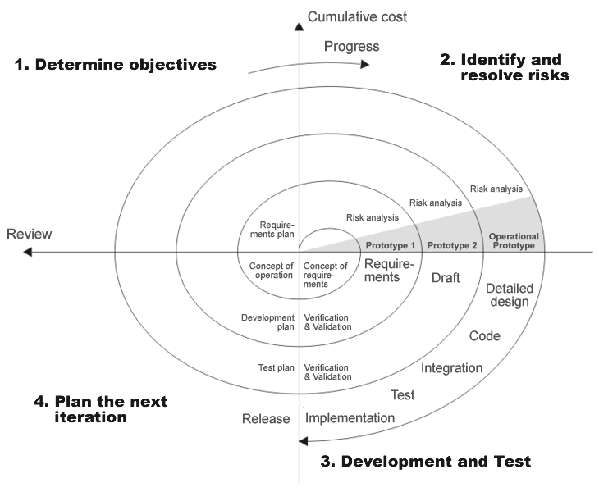

[This Photo](https://codeandwork.github.io/courses/prep/swDevelopment.html) by Unknown Author is licensed under [CC BY-SA-NC](https://creativecommons.org/licenses/by-nc-sa/3.0/)

**15. Write agile manifesto principle**

- Individuals and interactions over processes and tools.

- working software over comprehensive documentation.

- Customer collaboration over contract negotiation.

- Responding to change over following a plan.

- Meeting client requirement.

- Face to face talk.

- Support teamwork.

- Monitor the product cycle.

- Adjust strategies

**16. Write working methodology of agile model and also write pros and cons.**

**-** This agile methodology enables teams to quickly adapt to changing requirements.

The main focus of this process is continuous adaptation.

This methodology is a project management approach that involves breaking the project into phases and continuous collaboration and improvement.

Agile methods break tasks into smaller iterations, or parts do not directly involve long term planning.

This agile methodology is divided the software into small incremental builds. This build provided a iterations, that means a big project are divided into small parts or chunks.

**Pros**

* - Flexibility
* - Embracing uncertainty
* - Immediate feedback
* - Less defective product

**Cons**

* - Lack of documentation
* - Scope creep
* - Time
* - Lack of predictability

**17. Draw use case on Online book Shopping.**

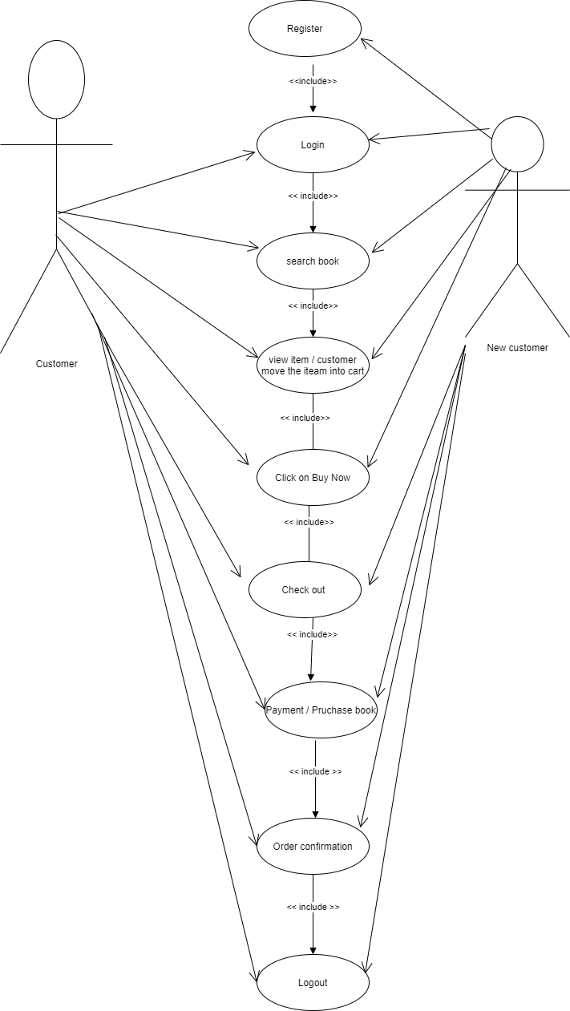

**18. Draw use case on online bill payment system(Paytm)**

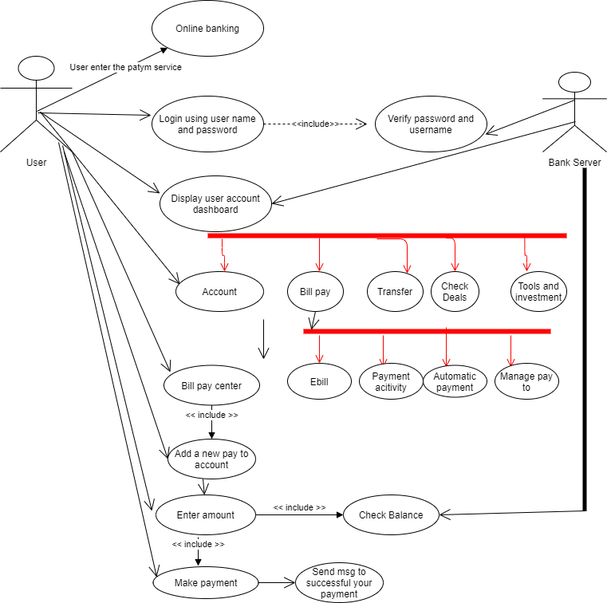

**19. Draw use case on Online shopping product using COD.**

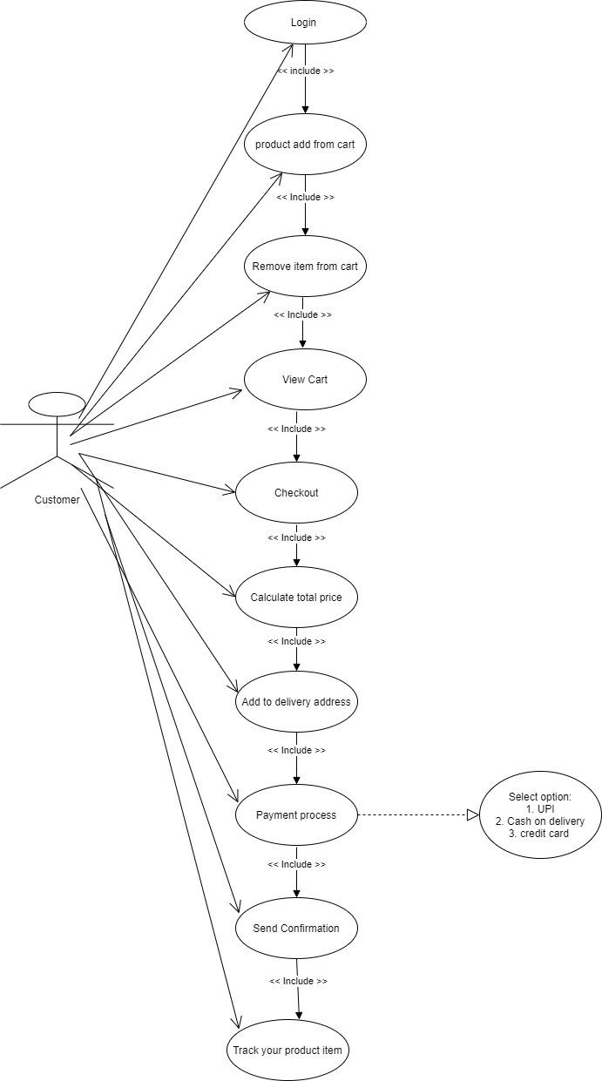

**20. Draw use case on Online shopping product using payment gateway.**

